
Bahria University, Lahore Campus
Department of Computer Science
Lab Journal 10
(Fall 2025)

Course: | Introduction to Data Science - Lab | Date: _______________
Course Code: | CSL-487 | Max Marks: 20
Faculty’s Name: | Mr. Muhammad Umar Tariq

Name: Khawaja Fahad Zia Enroll No: 03-134221-057 Class: BSCS 6A

Objective(s):
Upon completion of this lab session, learners will be able to:
- To understand and apply unsupervised learning techniques by performing clustering and dimensionality reduction on real-world datasets using Python.
- To implement and compare K-Means and Hierarchical Clustering algorithms, analyze cluster formation, and evaluate cluster quality using metrics such as Silhouette Score and dendrogram interpretation.
- To perform data preprocessing tasks, including feature selection, handling missing values, and standardizing numeric features to prepare datasets for unsupervised analysis.
- To apply Principal Component Analysis (PCA) to reduce high-dimensional data into lower dimensions, visualize the transformed data, and interpret explained variance and component importance.
- To develop analytical and visualization skills by creating scatter plots, interpreting cluster patterns, evaluating algorithm performance, and drawing meaningful insights from unsupervised learning results.

Lab Tasks:

Task1: K-MEANS CLUSTERING

Objective:
Use the K-Means algorithm to discover natural groupings in an unlabeled dataset and analyze cluster behavior.
Dataset: Mall Customers Dataset

Instructions:
1. Load and Explore the Dataset
- Import dataset in Python (Google Colab/Jupyter).
- Display first 10 rows.
- Check shape, data types, missing values.

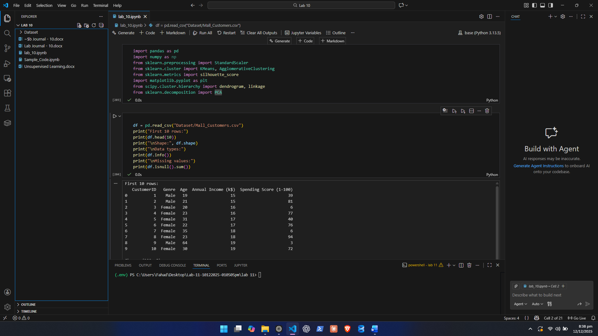
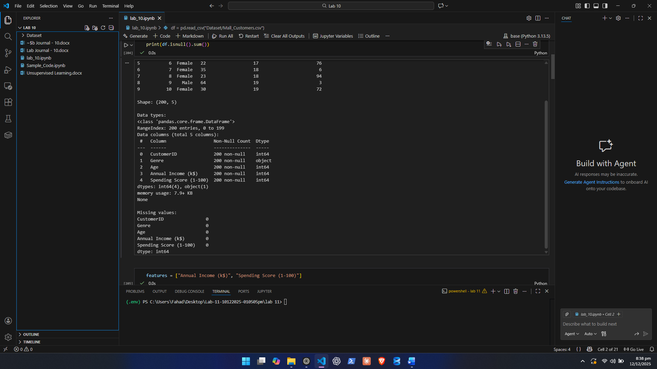

2. Select Features
Choose two or more numeric features.

3. Data Cleaning
- Handle missing values (if any)
- Standardize features using StandardScaler.

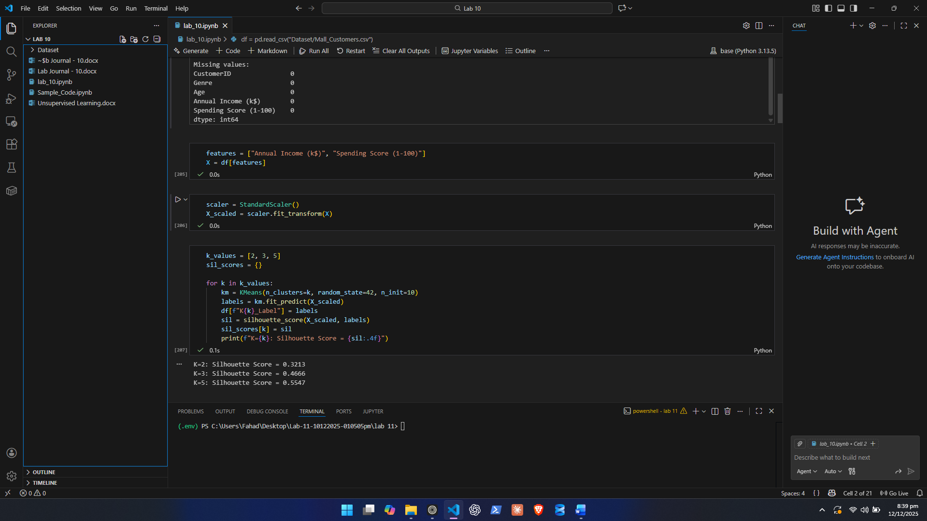

4. Apply K-Means for Different Values of K
Run clustering for:
- K = 2
- K = 3
- K = 5
For each K:
- Fit the K-Means model
- Predict cluster labels
- Add cluster labels as a new Cluster column

5. Visualization
Create scatter plots for each K where:
- X-axis = Feature 1
- Y-axis = Feature 2
- Colors = Cluster labels

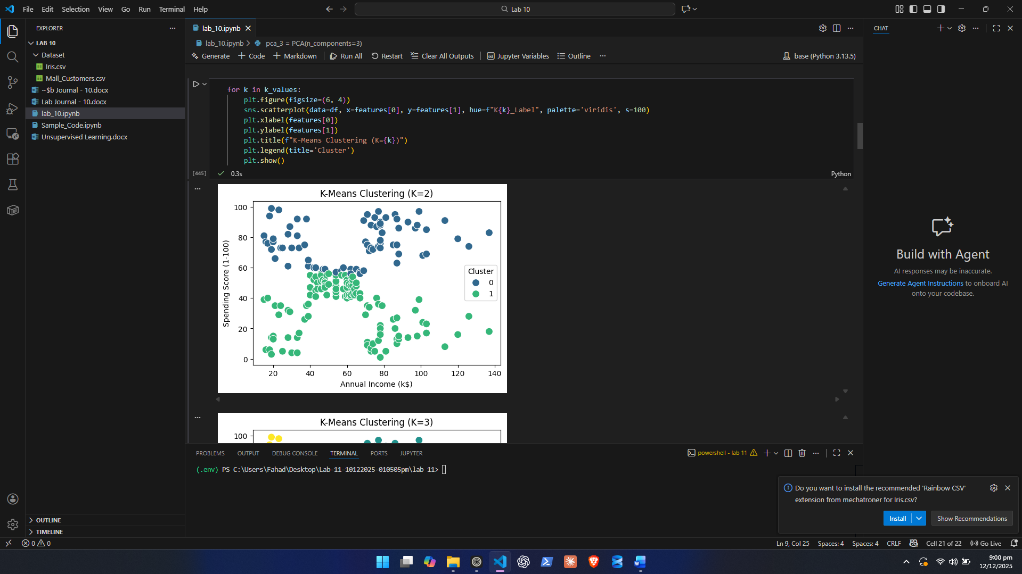
6. Evaluate Cluster Quality
Calculate and record:
- Silhouette Score for each K
Higher score = better cluster separation.

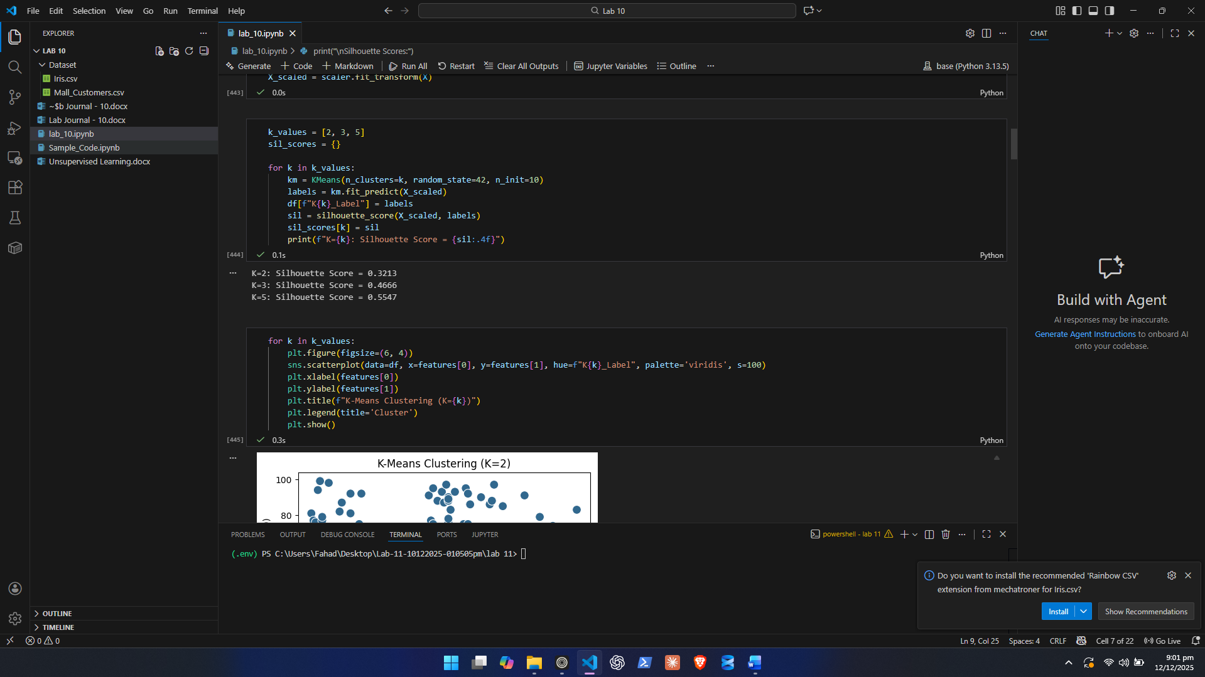
7. Analyse Clusters
For the best K value, describe each cluster:
Example: “Cluster 1 = low income, high spending score customers.”

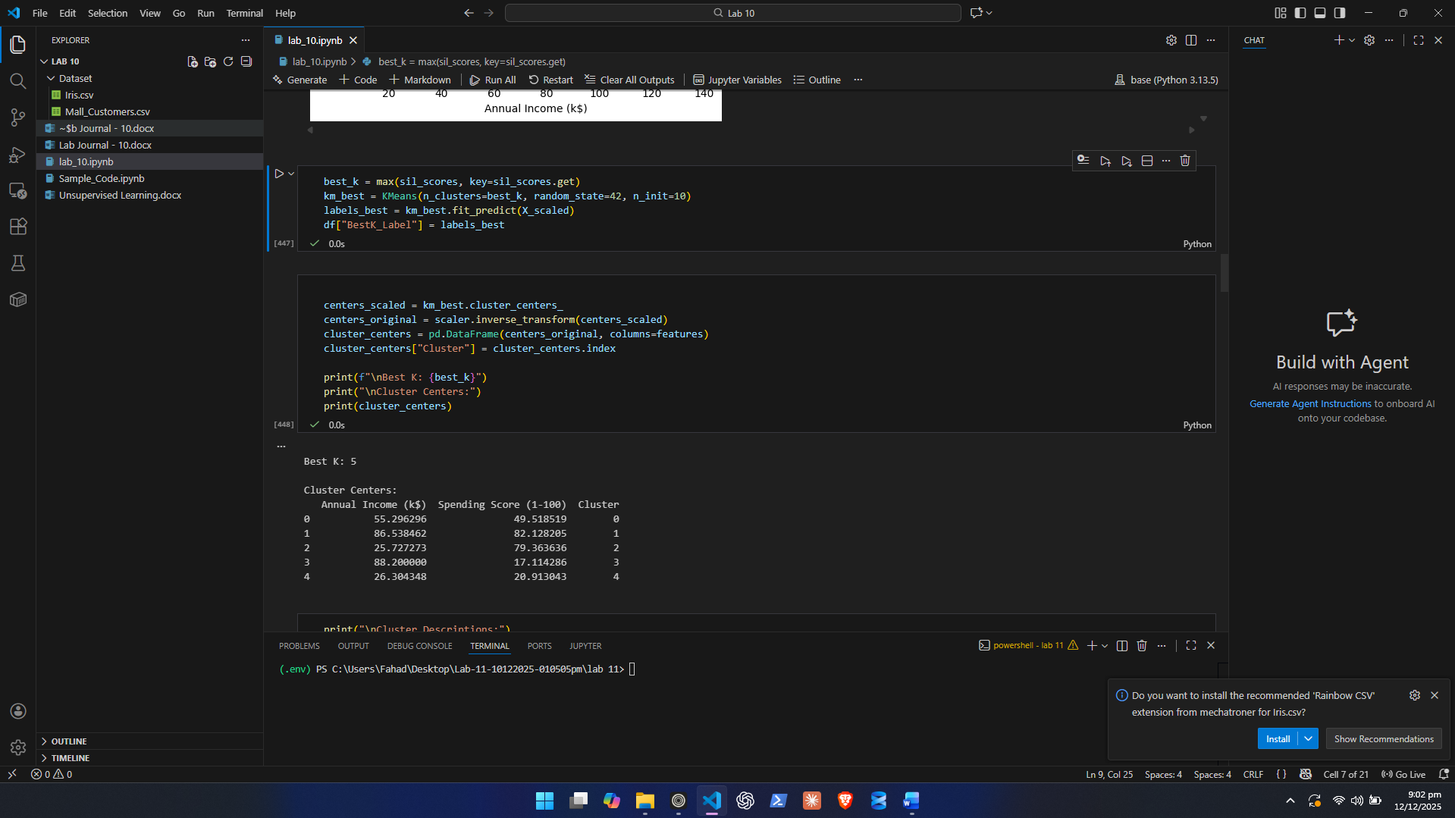
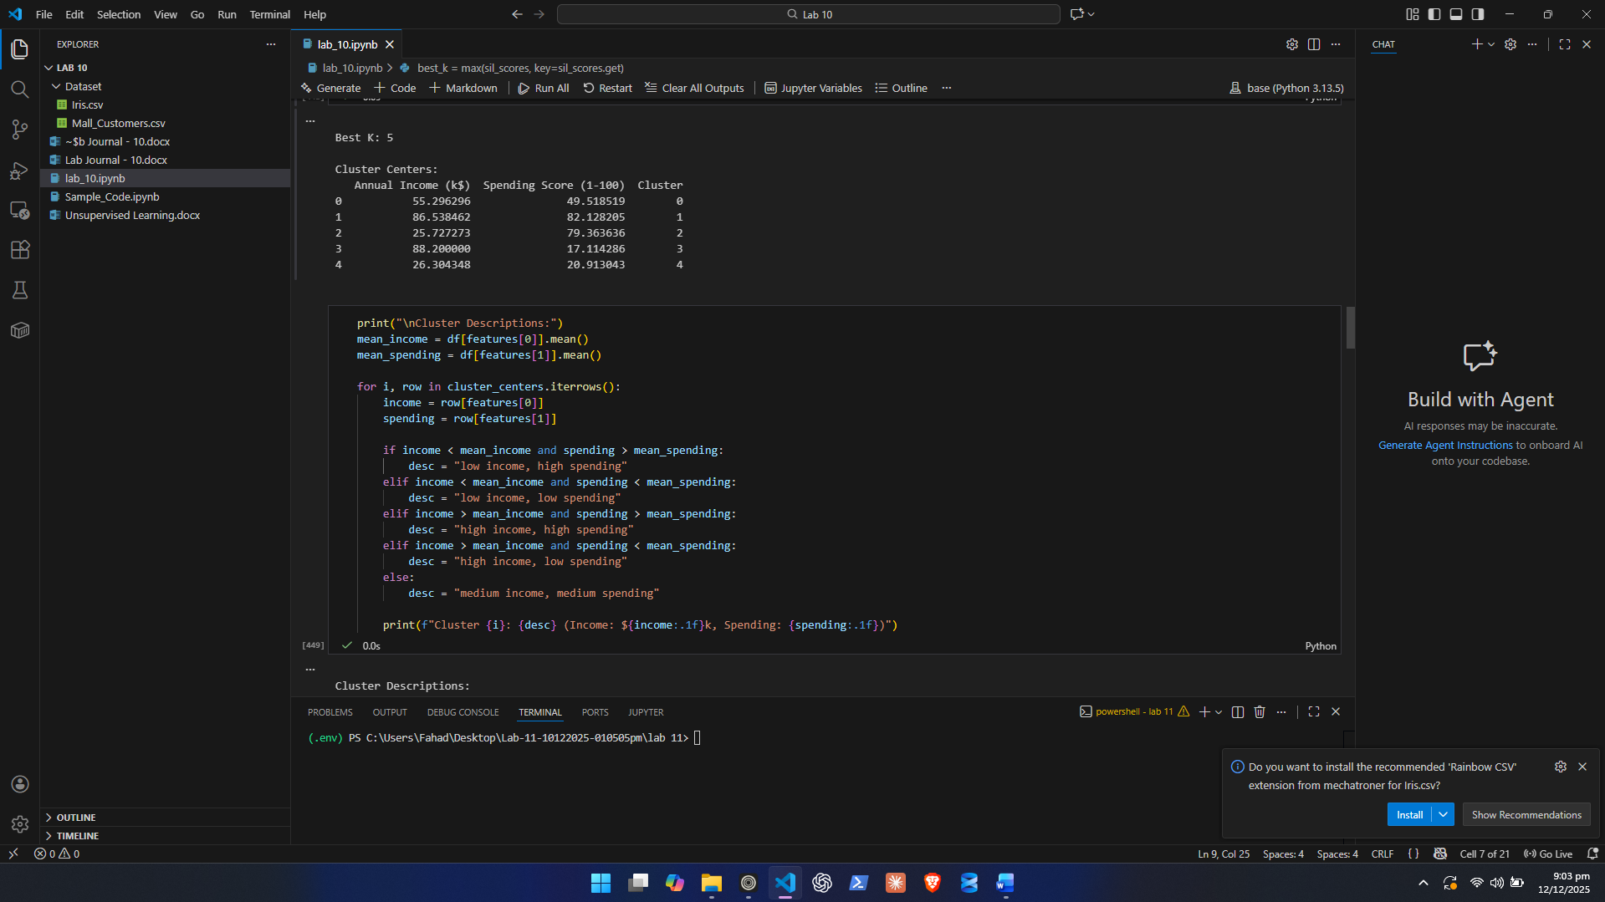

Questions to Answer:
- Which K value gave the best silhouette score? Why?
Best k = 5 with score = 0.554657. The Mall Customers dataset naturally forms 5 distinct behavioral groups based on Annual Income and Spending Score. K = 5 captures these groups with the best separation.

- How many natural customer groups did you find?

5 natural groups, consistent with the highest silhouette score and cluster centers.

- What defines each cluster? (behavior, patterns, differences)

Cluster Descriptions:
Cluster 0: low income, low spending (Income: $55.3k, Spending: 49.5)
Cluster 1: high income, high spending (Income: $86.5k, Spending: 82.1)
Cluster 2: low income, high spending (Income: $25.7k, Spending: 79.4)
Cluster 3: high income, low spending (Income: $88.2k, Spending: 17.1)
Cluster 4: low income, low spending (Income: $26.3k, Spending: 20.9)

- Did any clusters overlap? Why might this happen?

Yes, slight overlap occurs in the feature space.

- Income and spending scores are continuous variables, so some customers fall between clusters.
- K-Means assumes spherical clusters, but real customer behavior may not perfectly match that shape.
- Human behavior is naturally varied. Two customers with similar income might spend differently.

- Do the clusters make sense in real life? Explain with reasoning.

These clusters reflect realistic retail customer segments:
- Premium customers (high income, high spending), target for loyalty programs.
- Impulsive buyers (low income, high spending), trend-driven shoppers.
- Average shoppers (medium income, medium spending), regular mall visitors.
- Cautious wealthy customers (high income, low spending), selective buyers.
- Budget-conscious customers (low income, low spending), occasional shoppers.

Task 2: HIERARCHICAL CLUSTERING

Objective:
Perform hierarchical clustering to create a dendrogram and determine the natural number of clusters.

Dataset:
Use the same dataset as Task 1.

Instructions:
1. Load the Dataset
- Import and explore dataset
- Select 2–4 numeric features (same features used in K-Means)

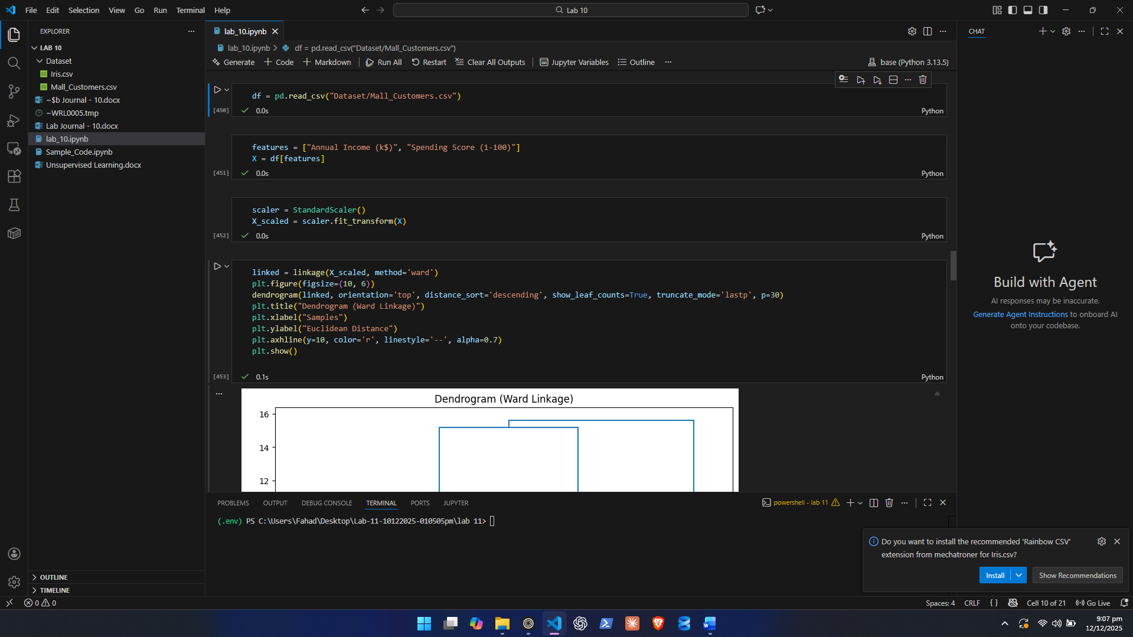

2. Standardize Data
- Apply StandardScaler
- Store normalized values for clustering

3. Generate a Dendrogram
Use SciPy to generate a dendrogram:
- Use linkage() with method = 'ward'
- Use dendrogram() to plot the hierarchical tree

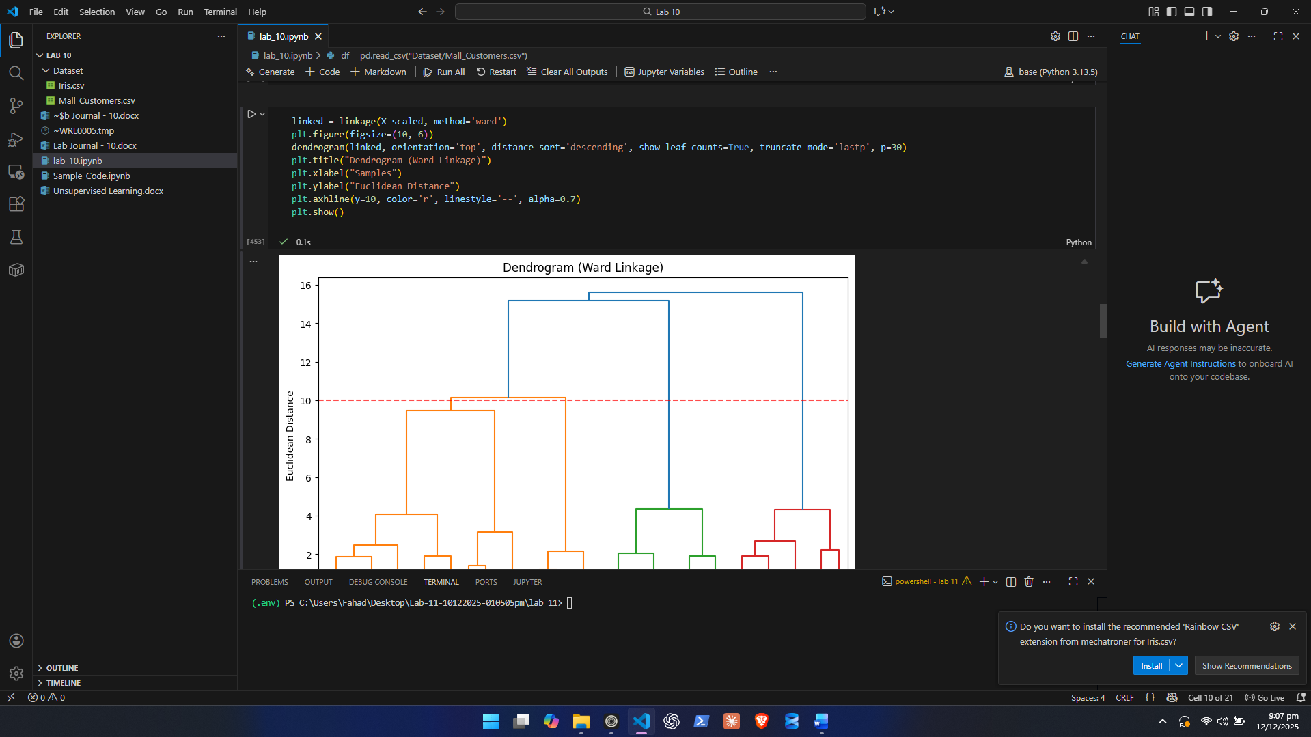
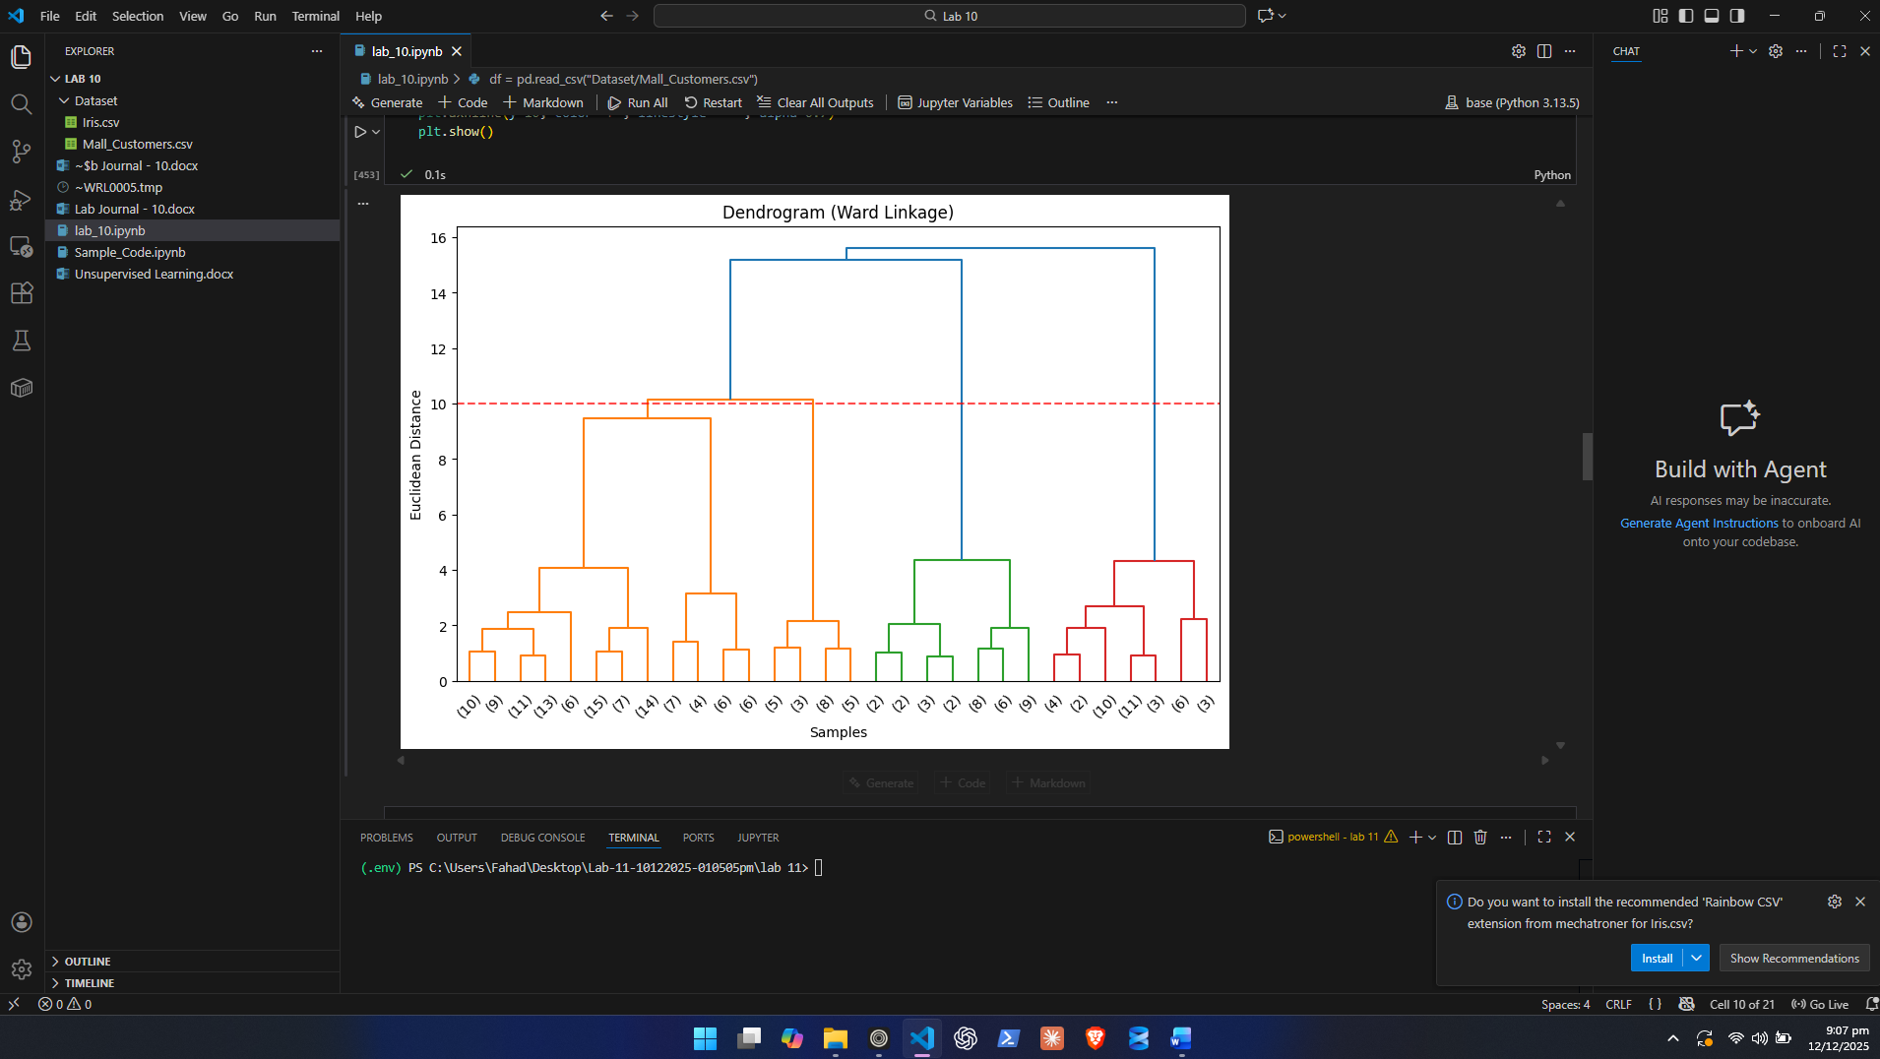

4. Perform Agglomerative Clustering
Use sklearn’s AgglomerativeClustering() with:
- Chosen number of clusters
- Linkage method: ward
- Affinity: euclidean
Add cluster labels to the dataset.

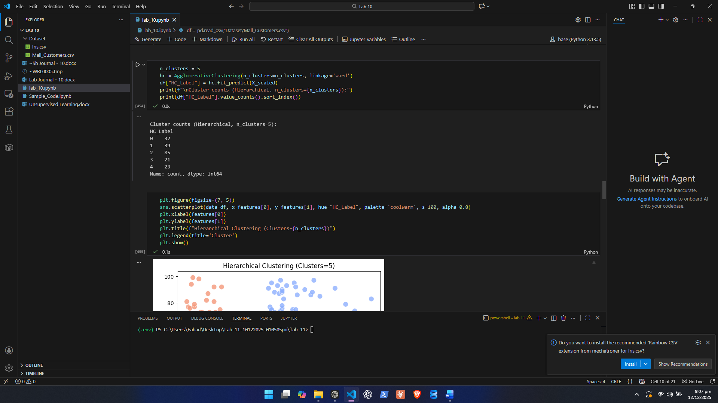

5. Visualize Clusters
- Create scatter plots using the same features
- Color points based on the cluster labels

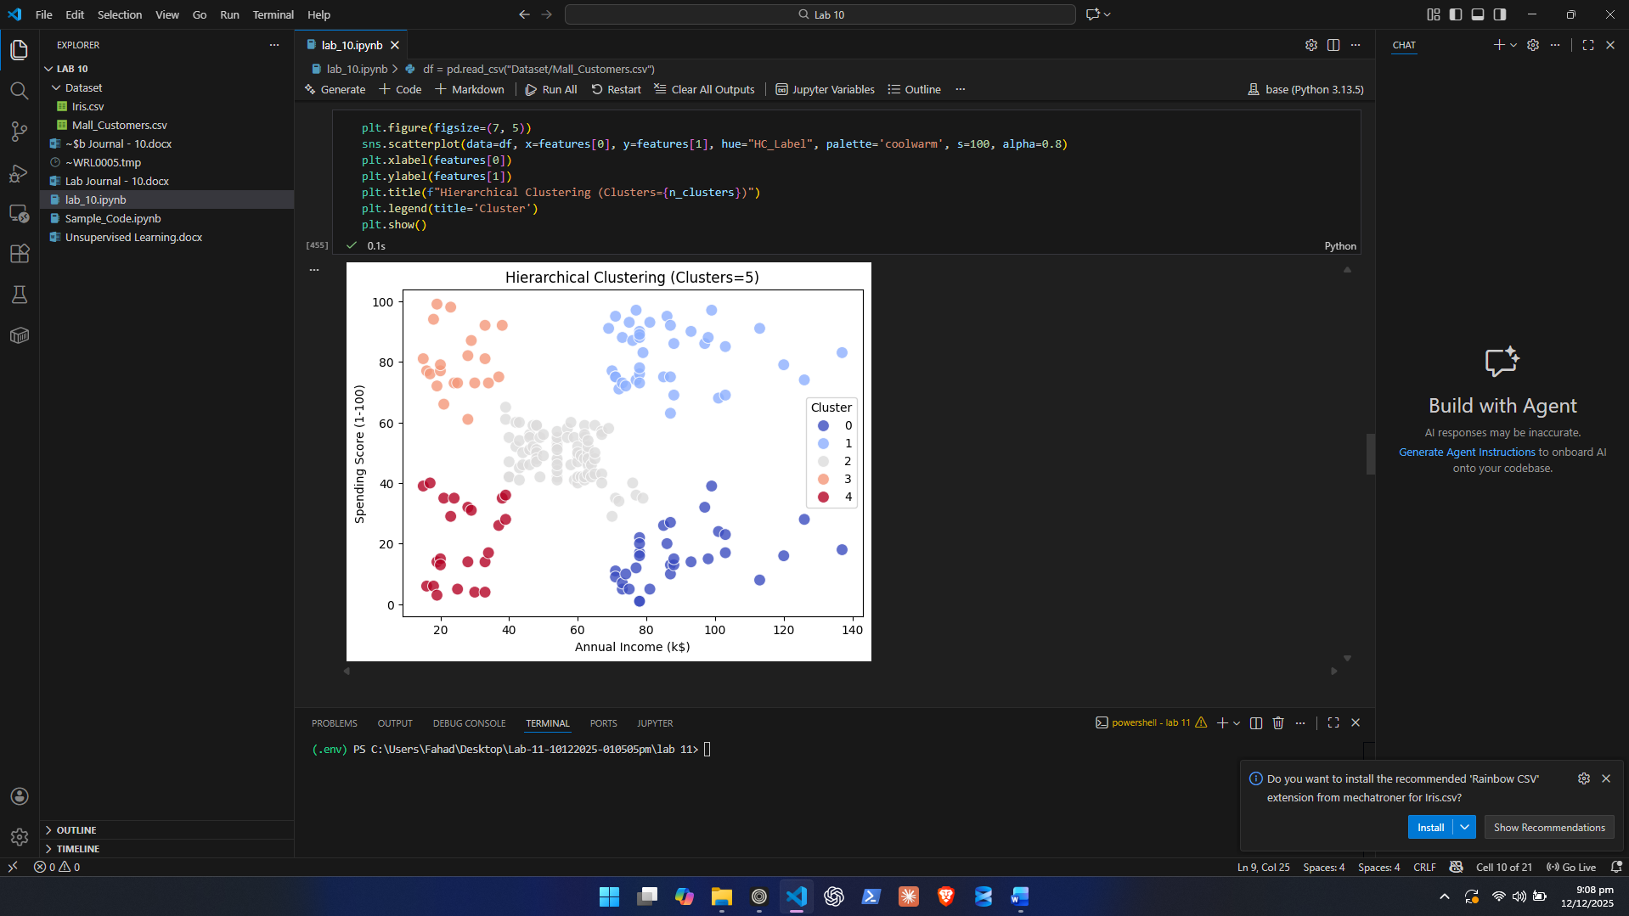

Questions to Answer:
- Where did you cut the dendrogram? Why?

- How many clusters were formed?

- Do these clusters match the clusters from K-Means?

- Which method (K-Means or Hierarchical) gives more realistic clusters? Why?

- What did the dendrogram reveal about similarity between data points?
Task 3: DIMENSIONALITY REDUCTION USING PCA

Objective:
Use Principal Component Analysis (PCA) to reduce the Iris dataset from 4 numerical features down to 2 or 3 components, visualize the transformed dataset, and analyze the amount of variance explained.
Dataset: Iris Dataset

Instructions
1. Load and Explore the Dataset
- Import the dataset into Python (Colab/Jupyter).
- Display the first 10 rows.
- Check:
  - Shape
  - Summary statistics
  - Missing values

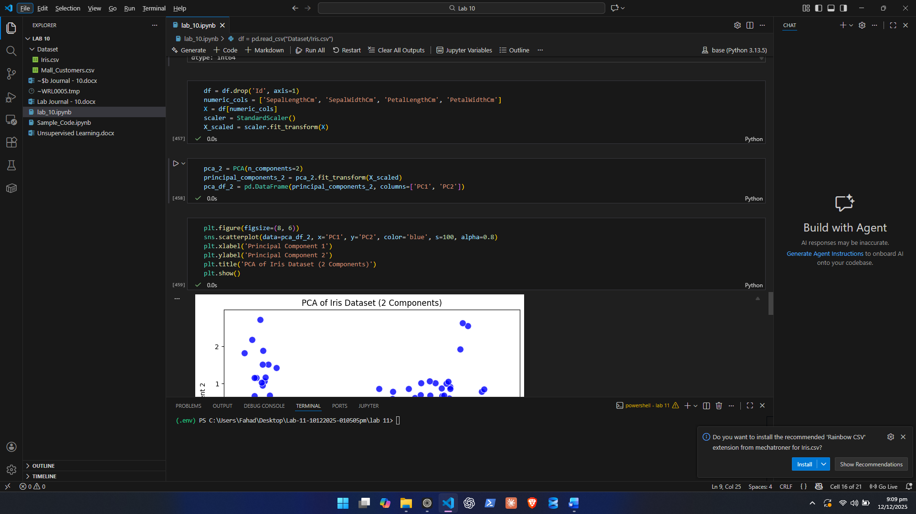
2. Prepare the Data
a) Drop the following:
- Id (not useful for PCA)
b) Select only the 4 numeric columns:
- SepalLengthCm
- SepalWidthCm
- PetalLengthCm
- PetalWidthCm
c) Standardize the features
Use StandardScaler to scale all numeric features to mean 0 and std 1.

3. Apply PCA
a) PCA with 2 Components
- Reduce dataset from 4 → 2 dimensions
- Save transformed data as PC1 and PC2
- Create a 2D scatter plot:
- X-axis: PC1
- Y-axis: PC2
- Color: Species (optional)
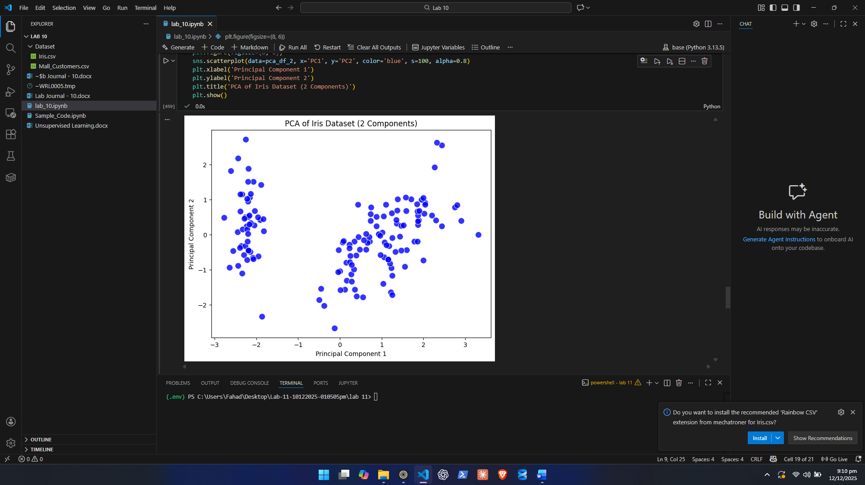

b) PCA with 3 Components
- Reduce dataset from 4 → 3 components
- Create a 3D scatter plot using PC1, PC2, and PC3

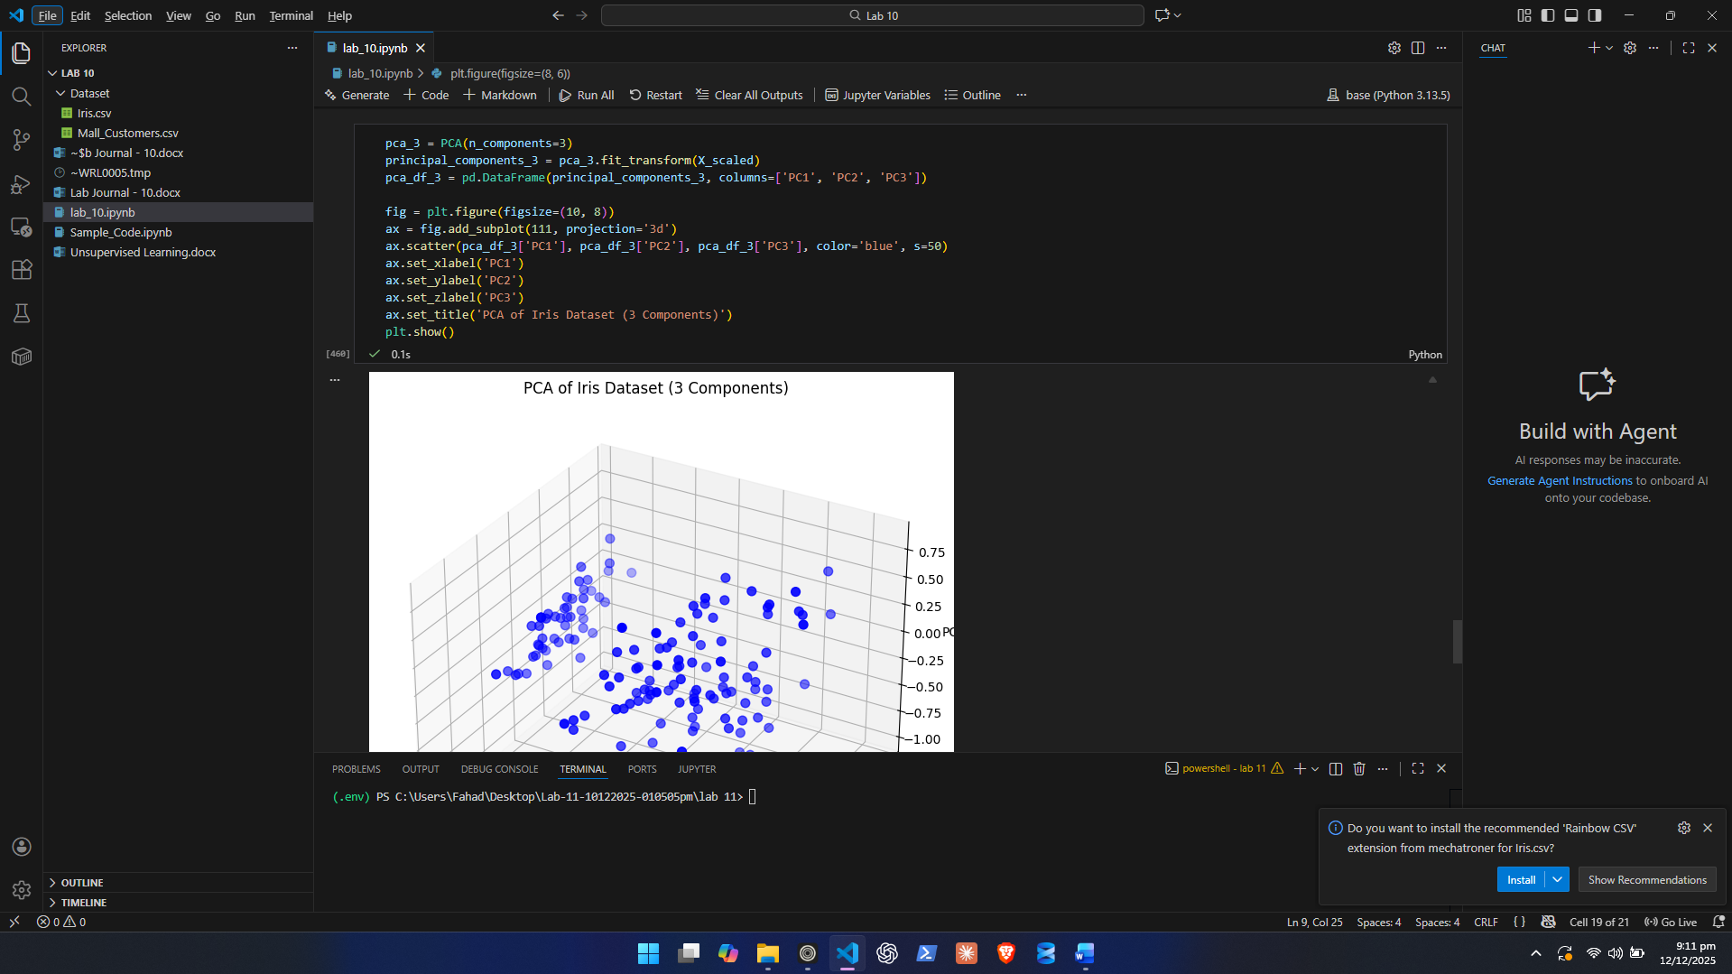

c) Record Explained Variance
For both cases (2 and 3 components):
- Report the explained variance of each component
- Report cumulative variance retained

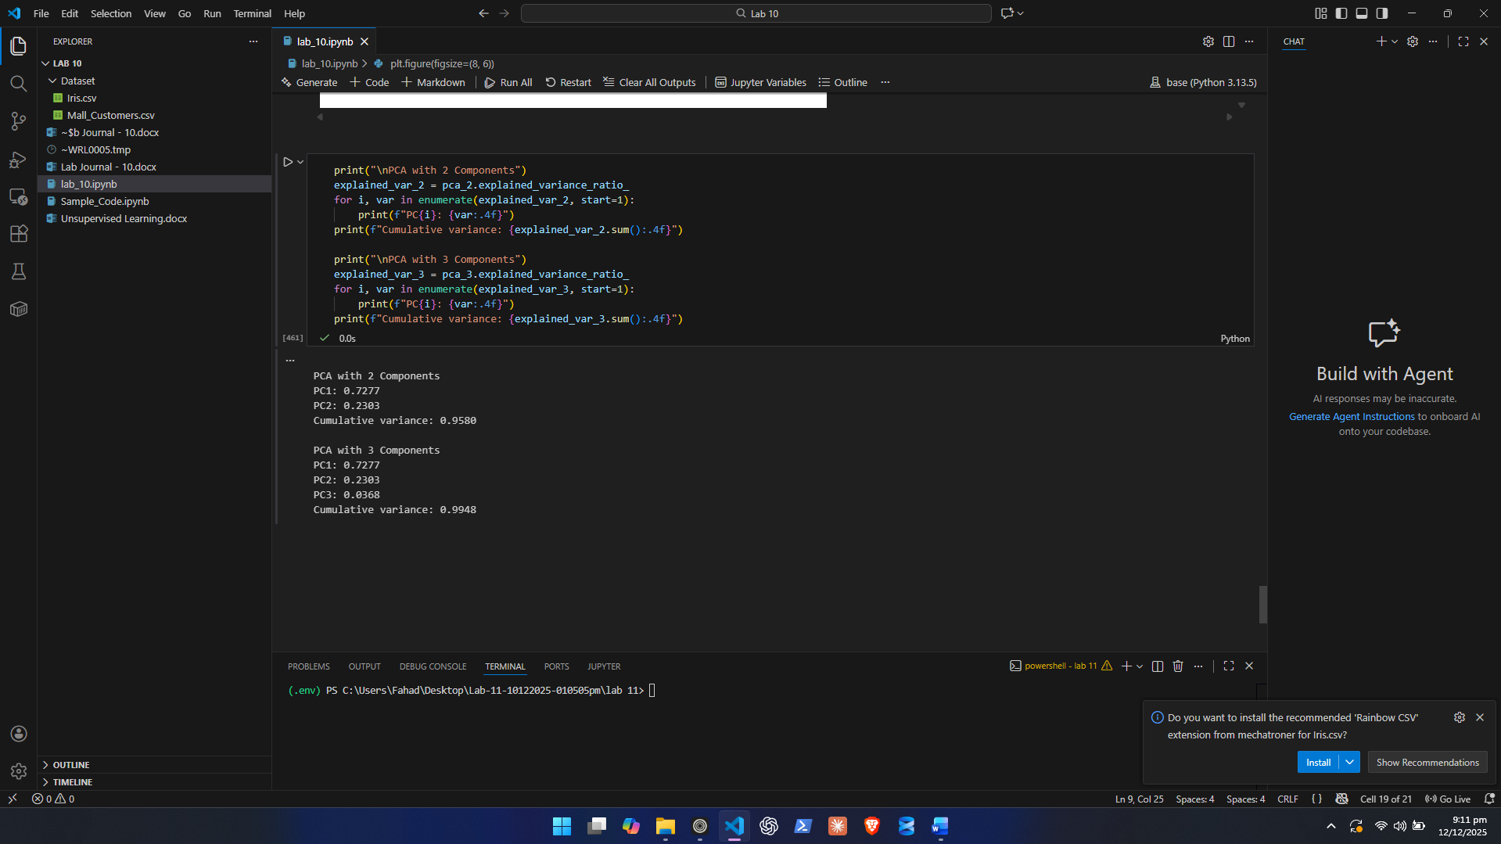

4. Interpret the PCA Results
Students must analyze:
- How much variance PC1 and PC2 explain

PCA with 2 Components
PC1: 0.7277
PC2: 0.2303
Cumulative variance: 0.9580

PCA with 3 Components
PC1: 0.7277
PC2: 0.2303
PC3: 0.0368
Cumulative variance: 0.9948

3rd Variable contributes way less and 1 and 2 capture most of the scenario at 0.9580.

- Whether the PCA scatter plot shows natural clusters

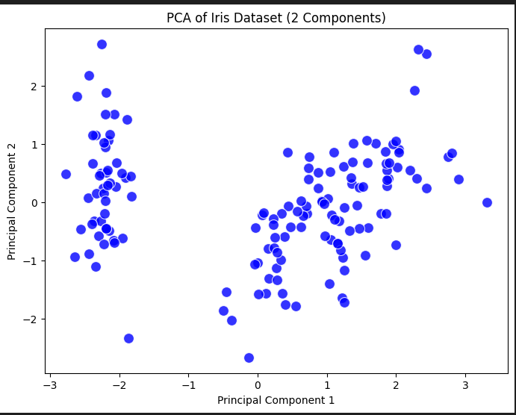

Shows 2 different clusters.

Lab Grading Sheet:
Task | Max Marks | Obtained Marks | Comments(if any)
1. | 10
2. | 10
3. | 10
Total | 30 |  | Signature

Note : Attempt all tasks and get them checked by your Lab Instructor.

